**V1:** Use the SH schema to write a query using SQL for aggregation to display the following report:

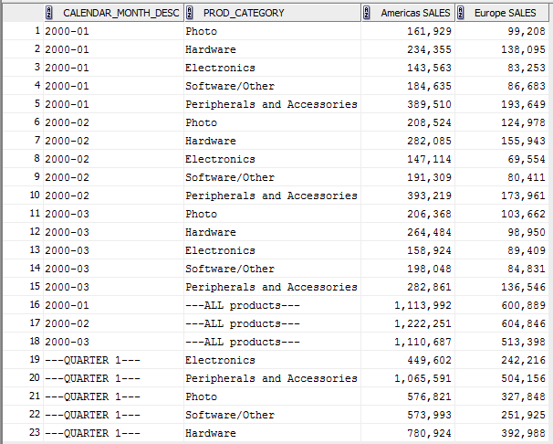

Conditions:

* **TIMES.CALENDAR_MONTH_DESC**: 2000-01, 2000-02, 2000-03
* **COUNTRIES.COUNTRY_REGION**: Europe, Americas.

**V2:** Use the SH schema to write a query using SQL for aggregation to display the following report:

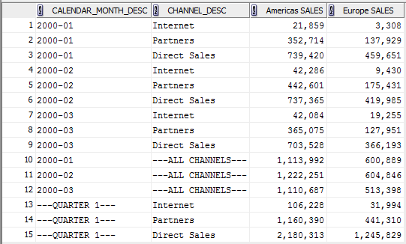

Conditions:

* **TIMES.CALENDAR_MONTH_DESC**: 2000-01, 2000-02, 2000-03
* **COUNTRIES.COUNTRY_REGION**: Europe, Americas.